PROJECT REPORT ON

**“Working with Attack Proof Web Server with automated backups of OS and Logs.”**

SUBMITTED IN PARTIAL FULFILLMENT OF REQUIREMENTS OF SUCCESSFUL COMPLETION OF SUMMER TRAINING

ON COURSE

**‘CLOUD-SYSTEM-ADMINISTRATION’**

SUBMITTED TO:

Prof. Rahul Gupta

Submitted by :

Gaurav verma

ID-250865



E&ict academy-iit.kanpur

**ACKNOWLEDGEMNT**

It gives us a great sense of pleasure to present the report on our summer term project on CLOUD SYSTEM COURSE. We own special debt of gratitude towards aur course mentor and teacher (Rahul sir), E&ICT Academy, for their constant support and guidelines throughout the course duration on our work. Along with this I am also very much thankful to E&ICT Academy for providing all the facilities that they could provide, it really helped me a lot. At last I would like to give a thanks to my friends for their help in successful completion of project on time.

**Problem statement:**

**You have to create one ec2 instance, which contains your website (PHP based). Database of website will be on RDS (My SQL). You have to create a s3 bucket which will sync logs and webpages of your https server in different folders, s3 bucket should synchronize after every 5 minutes. Configure all settings in Linux instance.

**Implement concept of auto scaling (1-3) with load balancer so that it will mitigate the overloading at peak time.

**You also have to create bucket life cycle for previous version of logs. After every 2 days previous version of logs should be deleted (or it could also be moved to glacier).

**SNS must be configured in order to get mail while instances are increasing and decreasing.

**Also configure snapshot of OS disk after every 12 hours and must retain last 2 snapshots

**Table of content:**

|  |  |  |
| --- | --- | --- |
| s.no | Topic name | Page.no |
| 1 | Working on EC2 instance  -that includes PHP webpages |  |
| 2 | Working on RDS(backend work) |  |
| 3 | To sync logs and webpages with s3 bucket |  |
| 4 | Concept of auto scaling and load balancer +SNS configure |  |
| 5 | Checking and observing the results |  |
| 6 | Configuring snapshots of os disk |  |
|  |  |  |

Introduction:

This project shows and explains very well, most of the main topics of the course CLOUD SYSTEM ADMINISTRATION that includes topics like global hosting, database management, web traffic management, balancing the system load, providing secure access to servers, regular backups and recovery system among other things. The main focus of the project is working with attack proof web server with automated backups of OS and LOGS. Moreover this project is one of the best example of general working of cloud and responsibility of a cloud administrator.

1.working on ec2 instance that includes php webpages

a)Under this step, our first task is to get ‘logged IN’ in our AWS account and create a fresh instance by going to…

🡪services

🡪EC2

🡪launch instance

While following the general steps of launch instance, we need to keep in mind that it’s important to select the HTTP and FTP rules along with SSH.

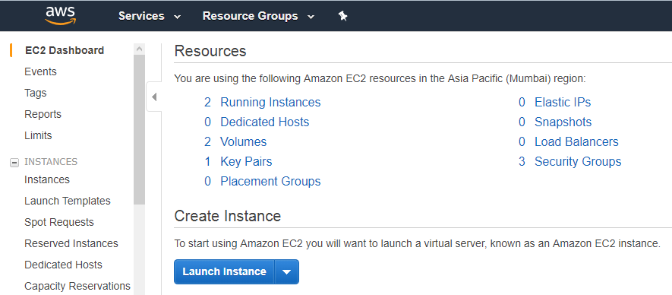

b) Our next step is to directly go into the working of our instance machine with the help of software known as PUTTY. The software requires public IP (along with a KEY) of the instance machine created and it then directly takes us to working environment of our instance machine. A sample is shown in the screenshot given below…

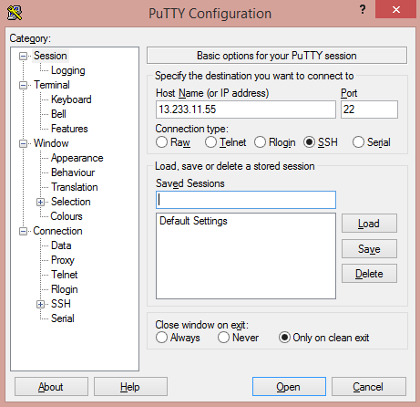

c)Now it’s time for us to go for the general configuration steps of FTP rule, but before that we need to do some general settings ….

🡪vi /etc/sysconfig/selinux

🡪make ‘ enforcing’ – ‘diasabled’

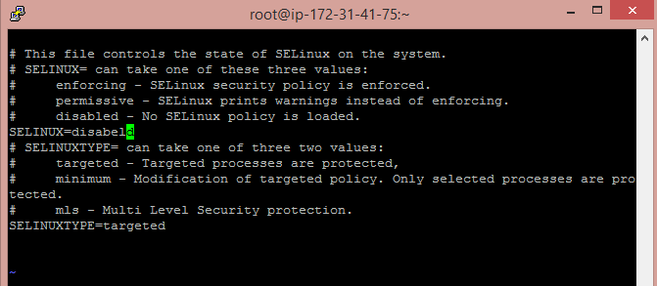

Now we can get forward with general steps of FTP configuration as given below..

1) yum install vsftpd httpd php* -y

#for installation of necessary packages…

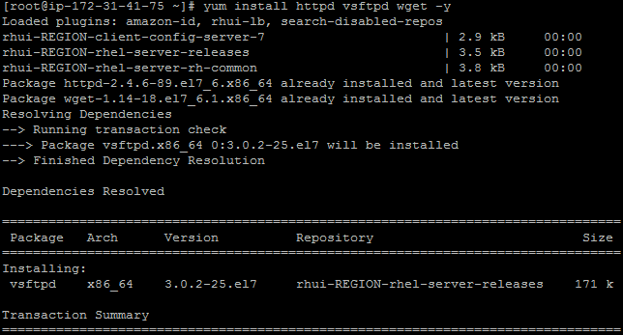

2)vi /etc/vsftpd/vsftpd.conf

#for providing access to specific user…

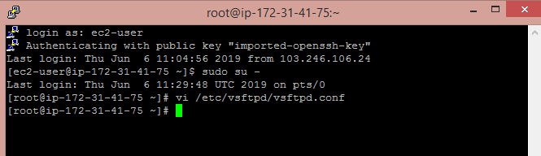

3)useradd <username>

Passwd <username>

<enter password>

#follow the steps for creating a specific user

4)chmod 777 /var/ftp/html

#for giving access to a particular location that will contain all the specific webpages required…

5)service vsftpd start

# for starting the required service, mainly for uploading the webpages files on the machine

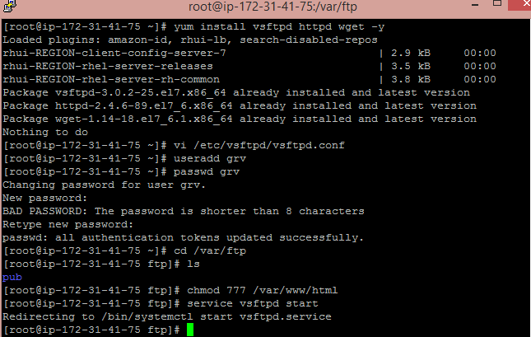

6)Now we need to move to cmd and upload the webpages to the desired location of machine…

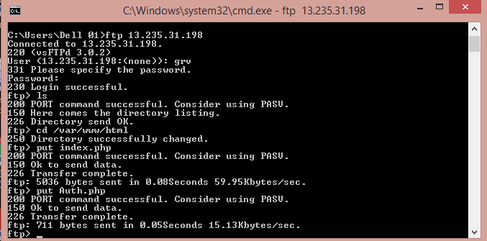

7)At last for global hosting we also need to start the httpd service also

Following the above steps we will be done with our first step and thus now we need to proceed with our second task that is based upon database.

2)working with RDS:

a)again under this step our first task will be to go to

🡪services

🡪RDS

🡪create database

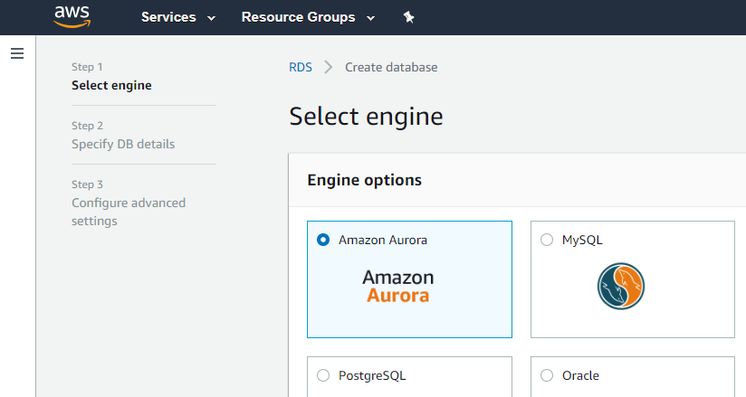

**Now we just need to move forward with the general steps involved in creating a new database that will be the backend for our PHP based web page. One very important thing which we need to keep in mind is, after the successful completion of database creation we will get an **endpoint** which will be very much useful in further steps .

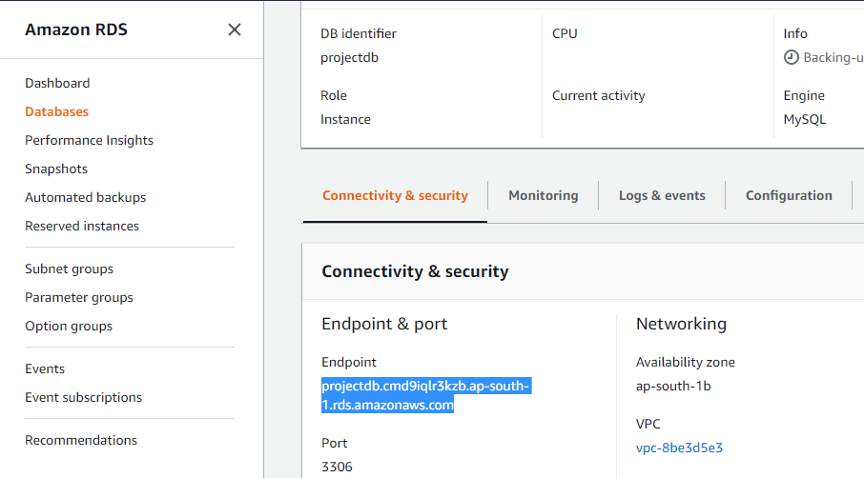

2) Now we need to move ahead with database configuration through our command prompt .

The steps we need to follow after switching to CMD are shown in the saved screenshot…

Steps involved in creating a database…

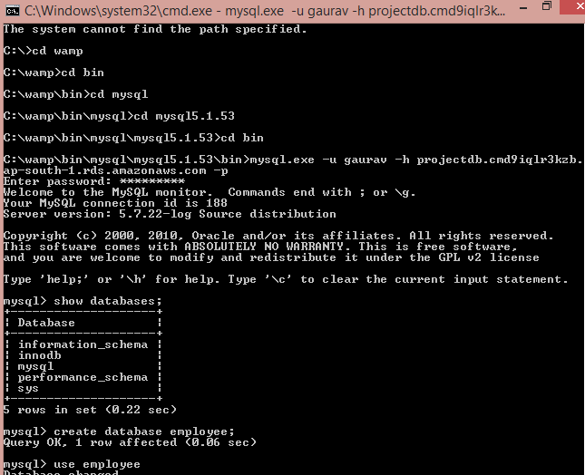

Thus we are done with all the necessary steps involved in creation of webpages and it’s linking with the database. The linking is already done in the coding files that were uploaded in the specified location while doing the FTP configuration

**Now a view of RDS connected webpage is shown….

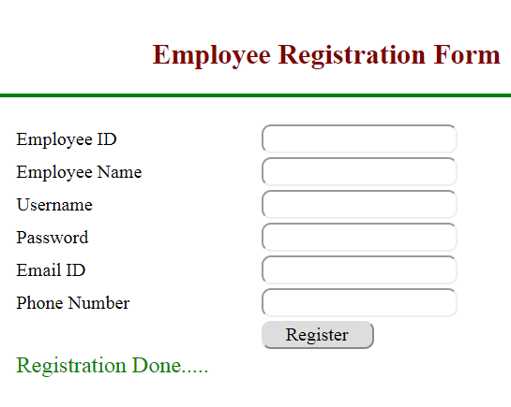

Here an image of successful use of webpage is shown….

Now we are done with one more step of our project. Thus moving ahead with next step to sync logs and webpages with s3 bucket

3) To sync logs and webpages with s3 bucket

As specified in the problem statement we also need to link the instance machine with the S3 bucket to keep the record of all the logs and PHP webpages used in the instance

a)The first task under this step is to go to

🡪services

🡪S3 bucket

🡪create bucket

**And thus following the general steps for creating a S3 bucket, here he S3 bucket name used is “iitkproject”…

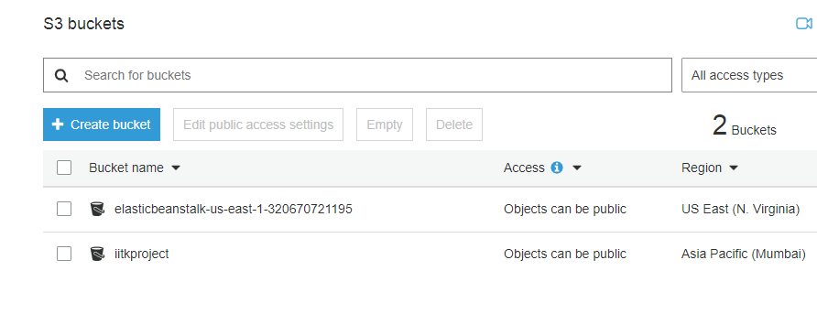

b)After creating S3 bucket we need to link it with the instance machine so that it can sync logs and webpages of our globally hosted website.Now the steps involved here are

1)firstly downloading the latest version of python, that will further help in successful installation pipe that is must required for AWS installation .

For installing python :

🡪yum install python*

# After the successful installation of python we need to go for some more installation and settings that is shown in the below saved screenshots.

2)

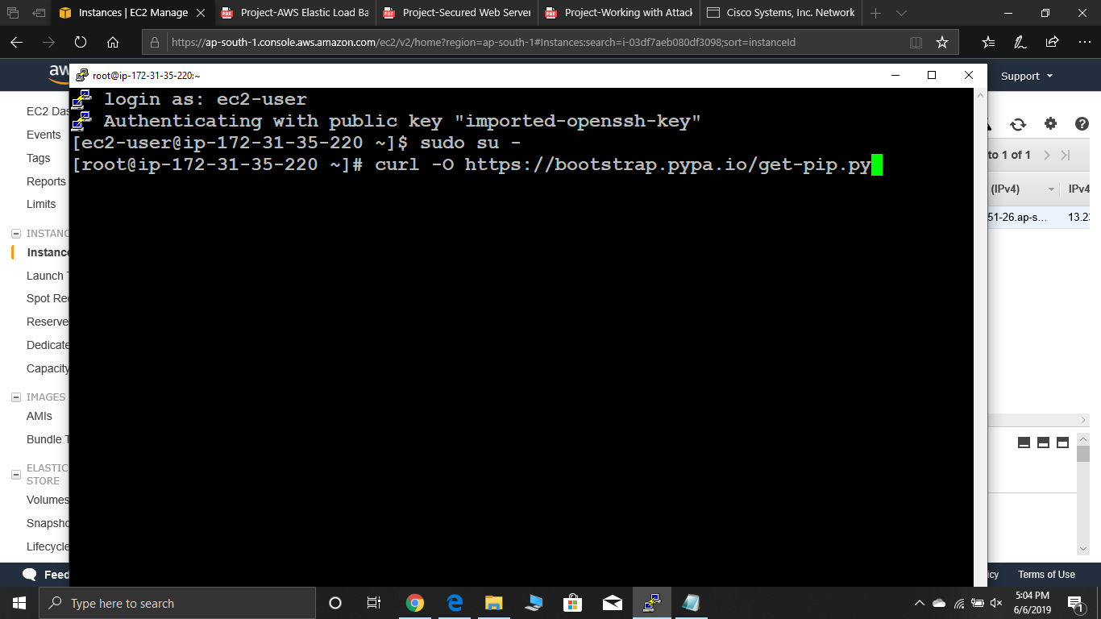

3)

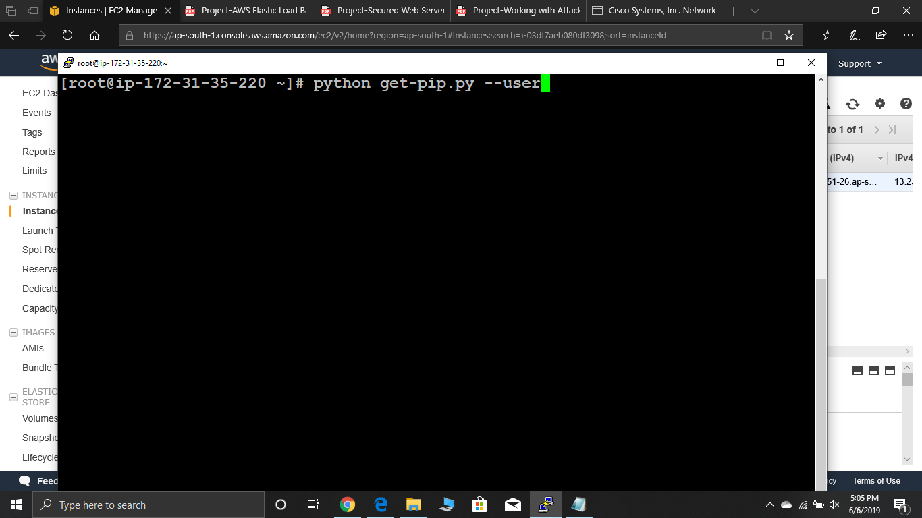

4) 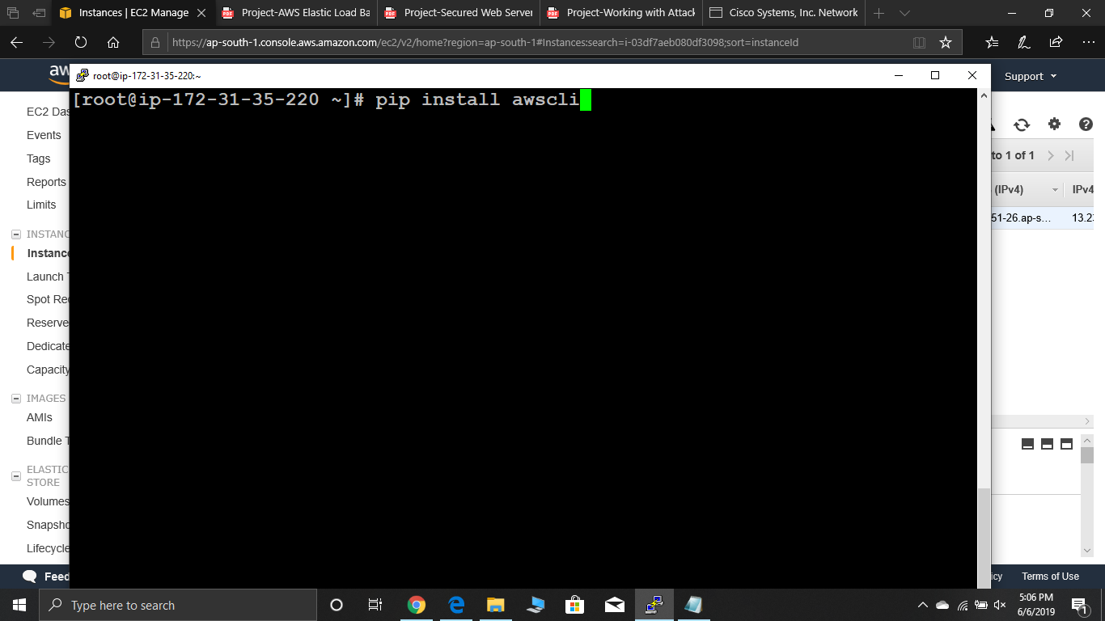

5)Now once we are done with the AWS installation we need to configure it for which we need to allow it’s access to particular AWS users. Thus it calls of a need for creation of an IAM user thus go to

🡪services

🡪go to IAM

🡪click on user and then create user, as shown in snapshot…

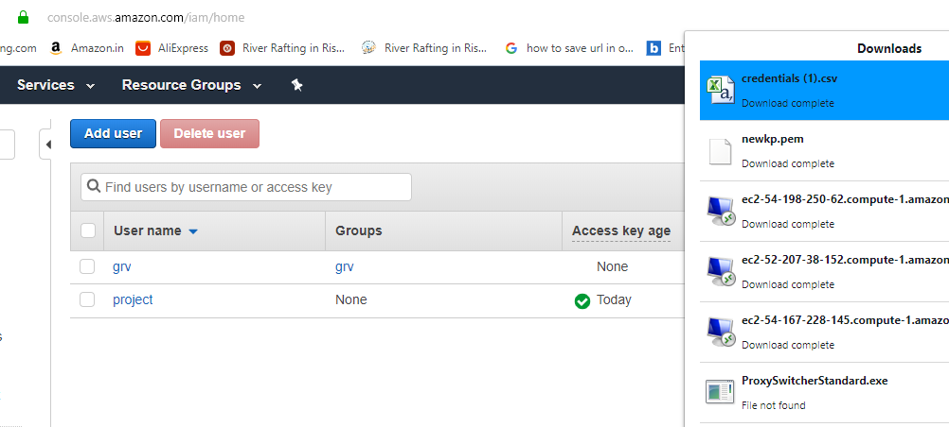

While we have created a ‘USER’ we will be able to download a file with .CSV extension that contains details that will help us to configure AWS

6)Now it’s time for us to configure AWS …

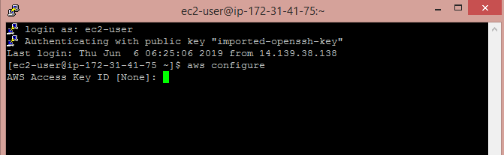

Thus follow the above shown steps and then enter the desired details from .CSV file downloaded while creation of specific USER

7) Once we have configured AWS we have reached to the final stage of our ‘SYNC’ task. Thus following the below shown commands in the shown manner we will be able to ‘SYNC’ webpages and files. So it’s shown here…

Steps to SYNC logs !

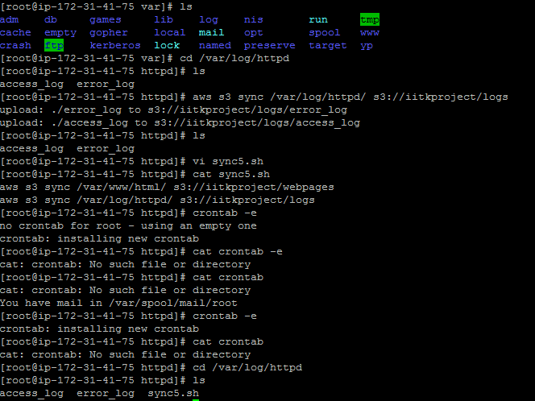

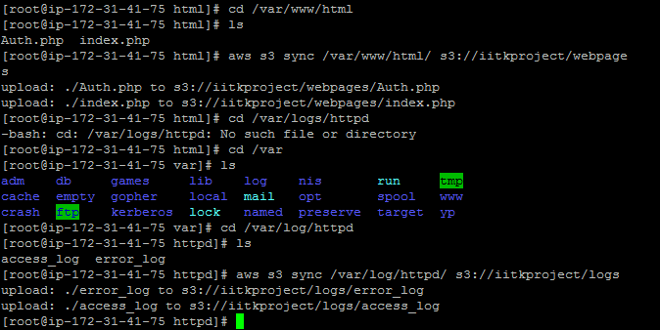

8)Thus we are done with our Sync task and now we should go and have a check at our S3 bucket….As shown in the screenshot..

S3 BUCKET FRONT PAGE:



ON CLICKING ON OUR IITKPROJECT WE’LL SEE…

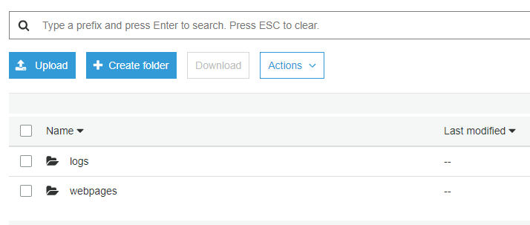

Thus for checking the logs creation, go inside it….

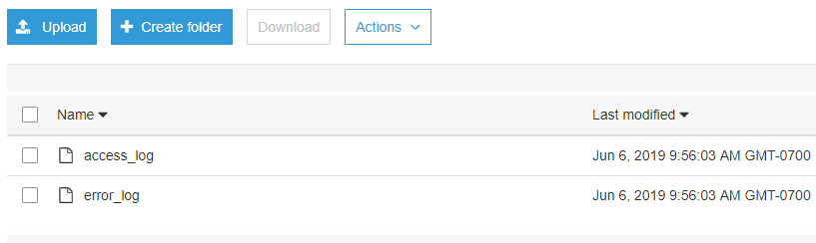

We can also check the content of our webpages folder..

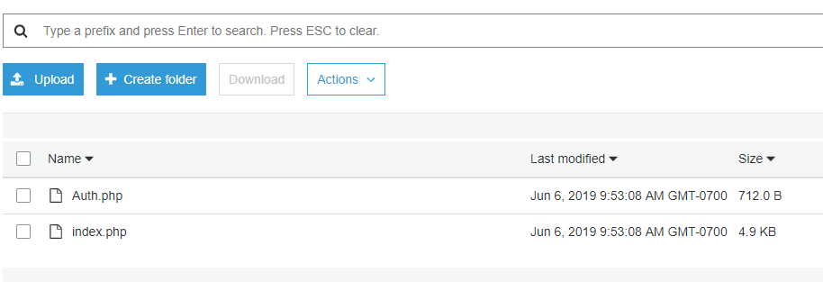

Hence we have successfully done our full SYNC task..

Thus we can move forward with our next step that will be the Concept of auto scaling and load balancer +SNS configuration .

4) Concept of auto scaling and load balancer +SNS configuration

As we know load Balancing concept is used to manage the traffic on our webpages while Auto scaling is used to manage the load that is build upon our instance machine. While these are done through the following steps…

1)firstly go to

🡪services

🡪click on EC2

🡪At right column click on load balancers, and move ahead with the general steps of creation BUT keeping two things in mind

*classical load balancer is to be created

*initially it will not contain any instance machine, however lately an instance will be added once it is connected with autoscaling. After load balancer creation you observe this…

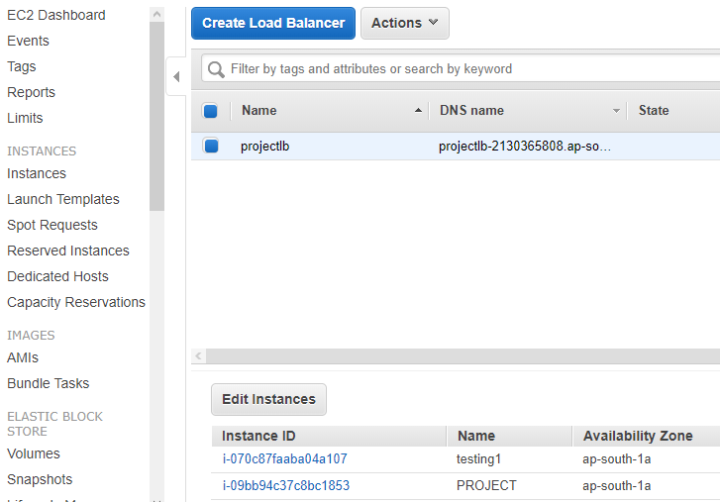

Once we are done with the creation of load balancer we need to move to creation of auto scaling that requires launching a configuration initially.

2) Thus for creation of auto scaling you can just go to

🡪services

🡪EC2 instance

🡪launch configuration

You just need to go with common configuration steps that will include fixing storage, adding rules among other things. As soon as we complete these steps we need to go to “create auto scaling groups”

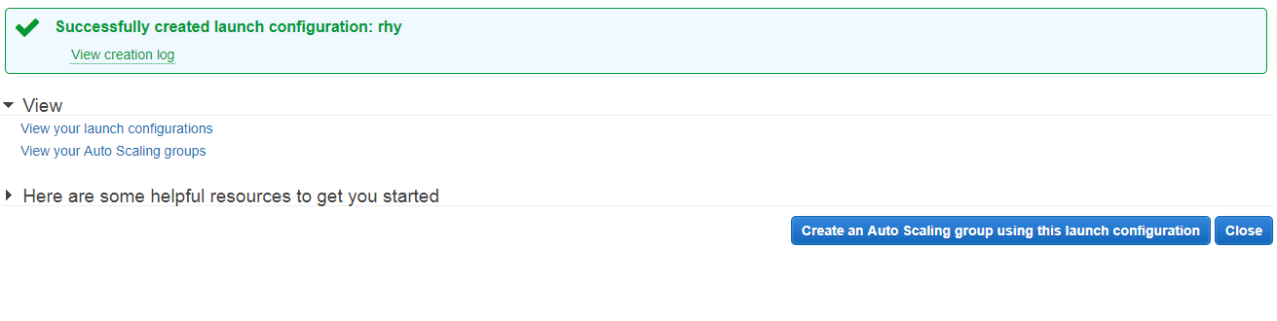

3)Now we need to proceed with the step of creation of auto scaling group , by clicking on the above shown step.

🡪Move ahead with the general steps BUT on the first page remember to mark the option of “receiving traffic from load balancers” as shown in the screenshot then only BOTH of them will work together….

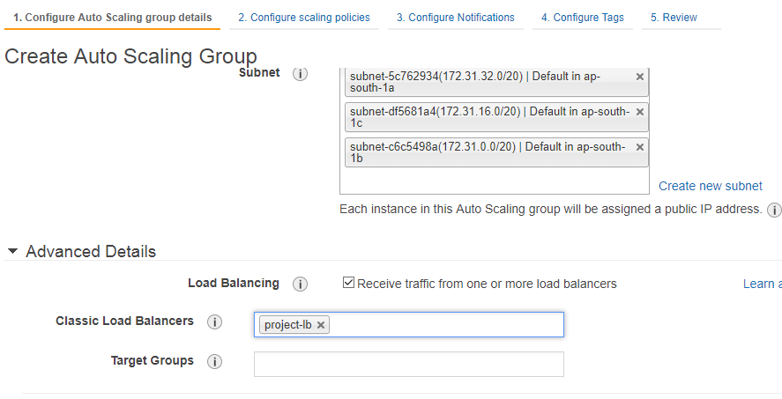

4)Now further we need to move forward with more configuration options in between we need to select the given particular option as shown…

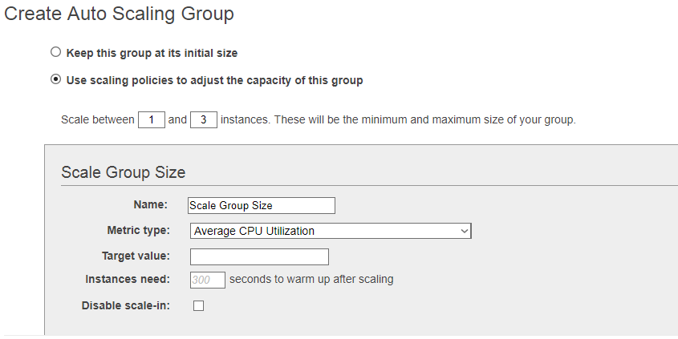

5)Now we need to move forward with creating alarms in alarming options..

(INCREASING ALARM)

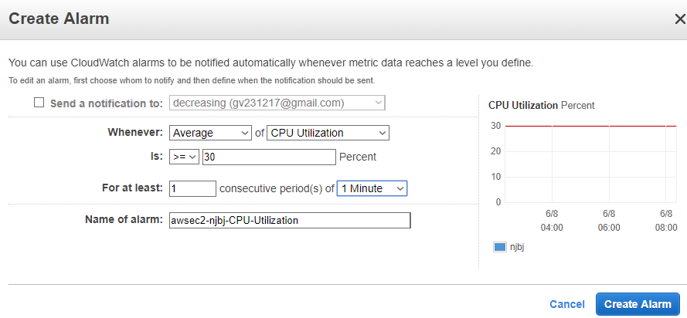

6)Similarly we create here DECREASING ALARM…

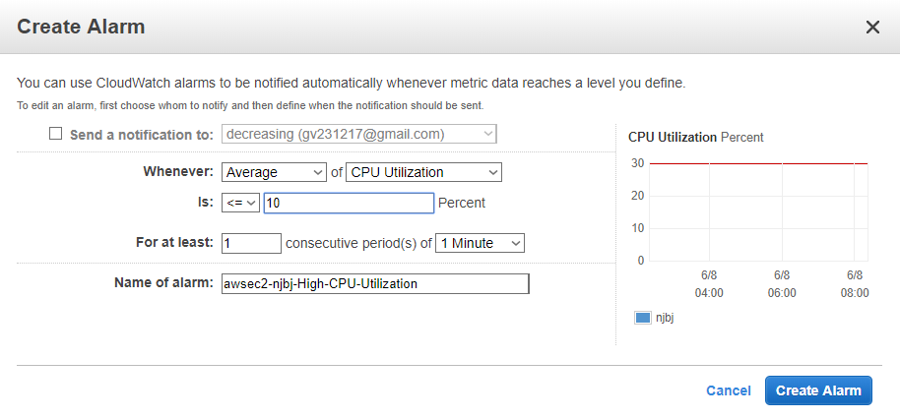

8)At last just before moving towards the final step we need to configure notification option (SNS CONFIGURATION)

Basically here we are configuring SNS ( Notitfication ) , that will inform us through e-mail about the actions striking and the load values of the machine..

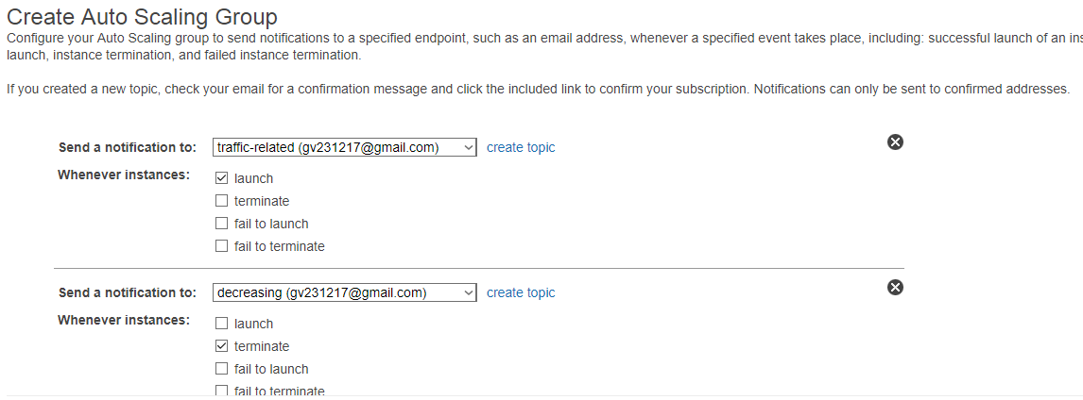

9)Thus moving ahead now we just need to review and thus our final autoscaling group will be created as shown…

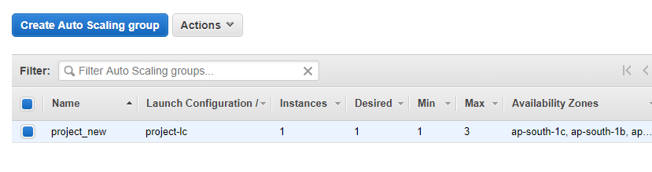

🡪So thus after the final step we will get to see a new instance being created and thus we are done with all the tasks of this step.

5) Checking,observing and confirming the results

🡪Webpage creation with database:



🡪S3 sync proof:



🡪versioning & lifecycle of bucket

-Go to properties set after clicking on the particular name of your S3 bucket, you will get to see the below shown …

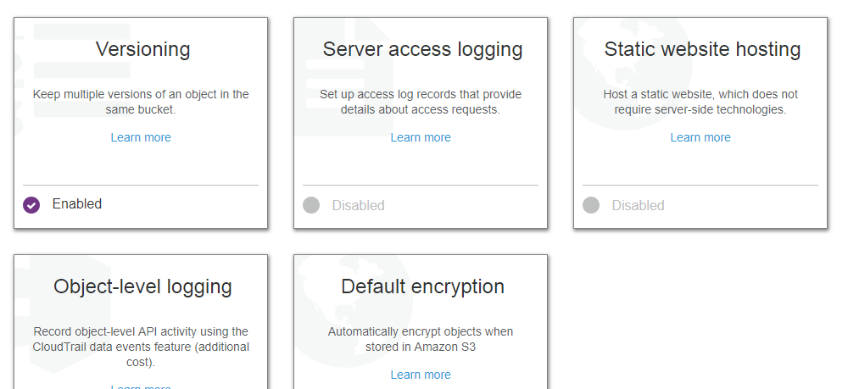

Thus thereafter enable versoning (for backup of logs) and further after sometime when you intentionally increase load to check versioning and the working of load balancing and auto scaling…

🡪confirmation for versioning…

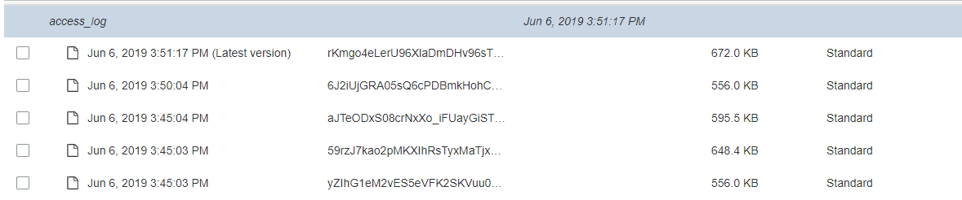

🡪confirmation on working of auto scaling and load balancers…

1)when load is increased-(instance is created)

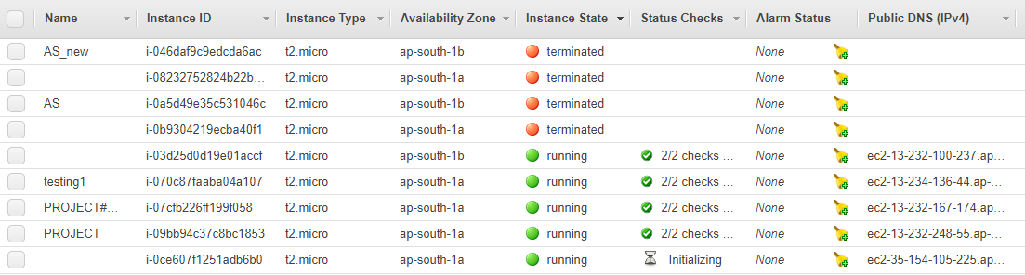

Thus here we can see one extra instance created

2)when load is brought down –

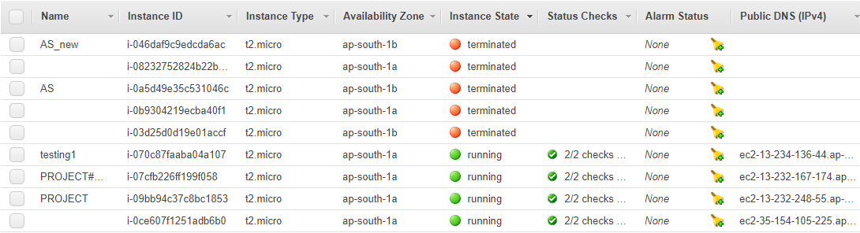

Here the instance gets terminated

3)SNS notification confirmation through mail as shown below in the image

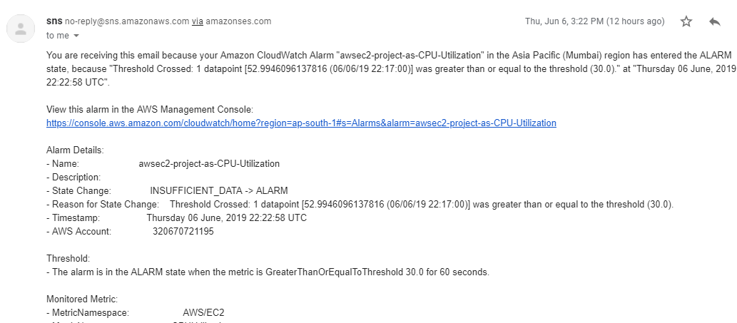

Thus here we have shown properly the working of different parts of the project..

6)regular snapshot creation(OS DISK):

Thus creating snapshots of our OS disk (volume) can be possible by going to

🡪EC2

🡪Go to snapshot lifecycle

🡪create a cycle for snapshot creation of only last two days

🡪we will get to see the above –

Once we have created a lifecycle:

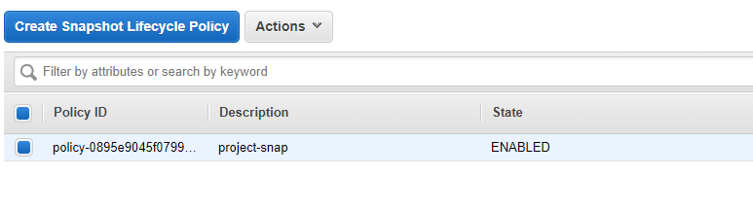

Moving ahead automatically a new snapshot will be created..

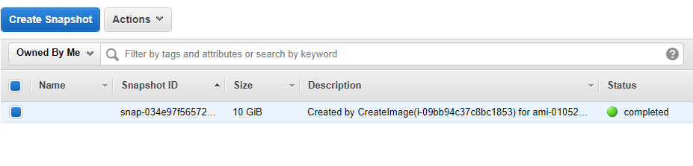

So thus we are done with all the required tasks and jobs that were to be done also we have solved the problem by ticking all the boxes and further making the server attack proof with the help of an IAM user creation.

🡪future scope & limitation:

Well this project has got a wide future scope since these days we often sees more & more companies coming up with server based application , so thus it becomes very much important for us to make the web server attack proof. However it cannot handle severe hacking attacks and for it we may need advanced security options.

**Thank you!**